OPSC6311 FORMATIVE 2

Mbali gebuza, Ayanda Boitumelo Hope Mngomezulu and Chomba tiku mwape

2025

# LANDING PAGE

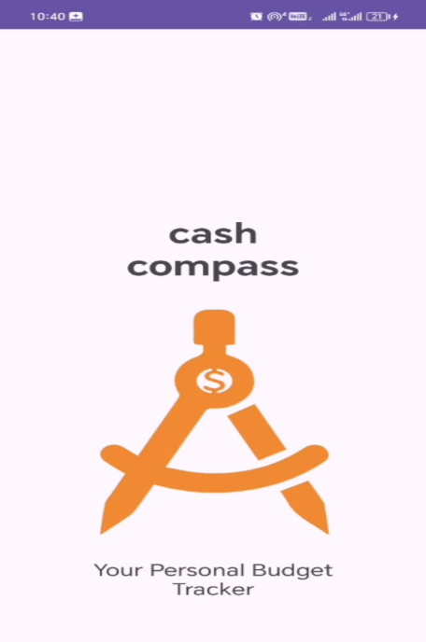

# REGISTRATION PAGE

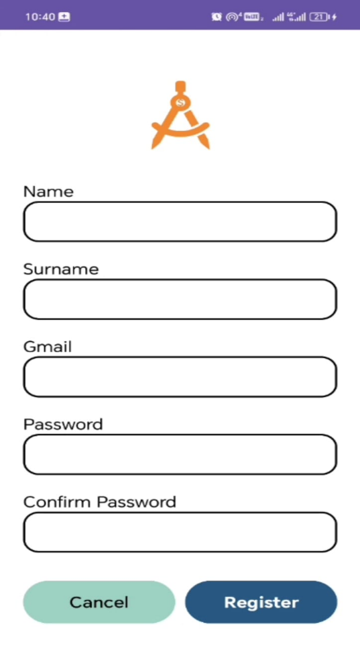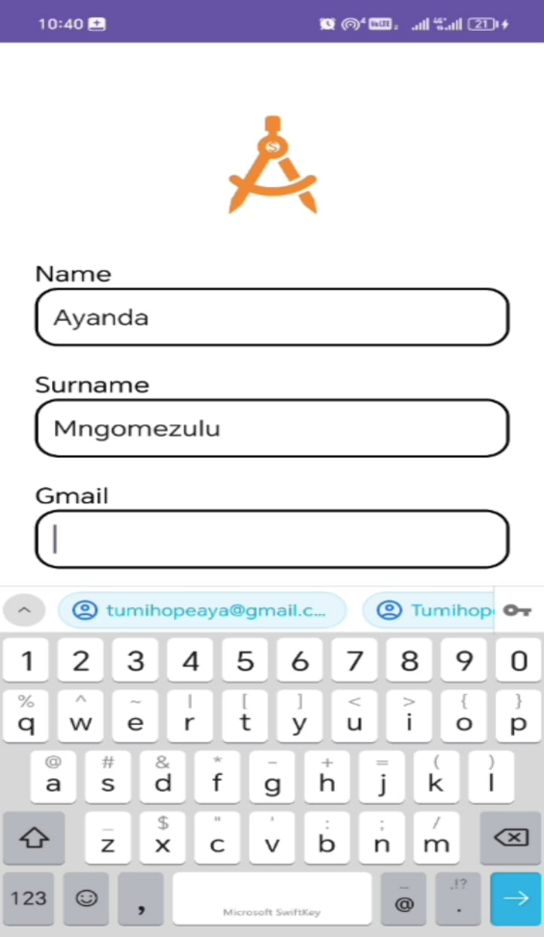

# LOGIN PAGE

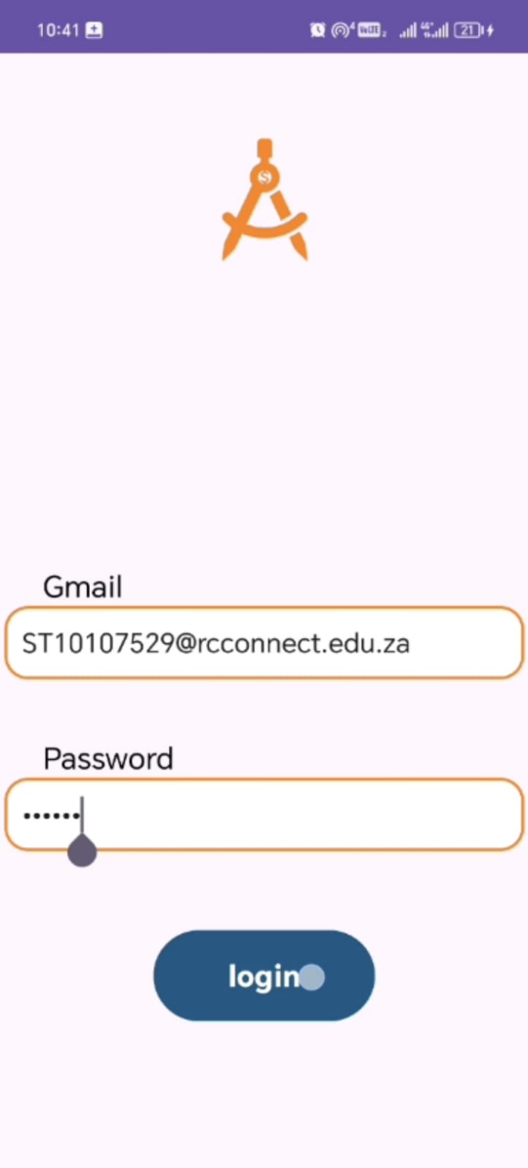

# DASHBOARD /HOME PAGE

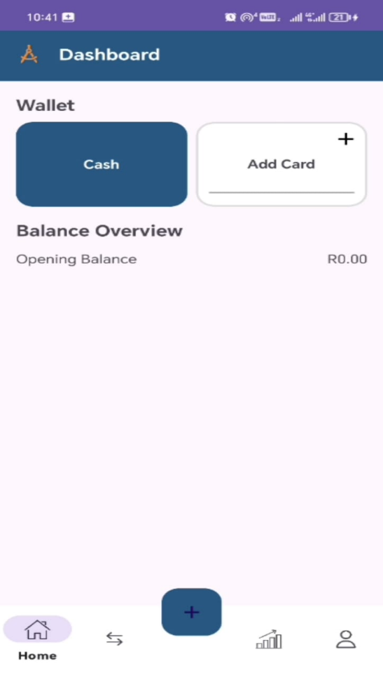

# TRANSACTION PAGE

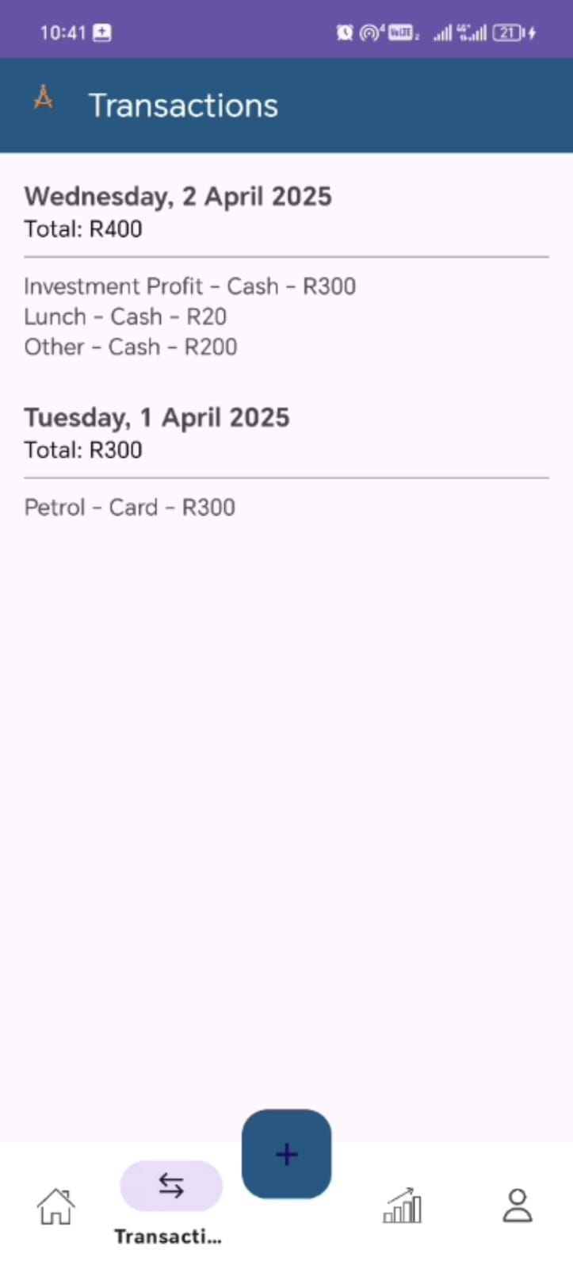

# PROFILE PAGE

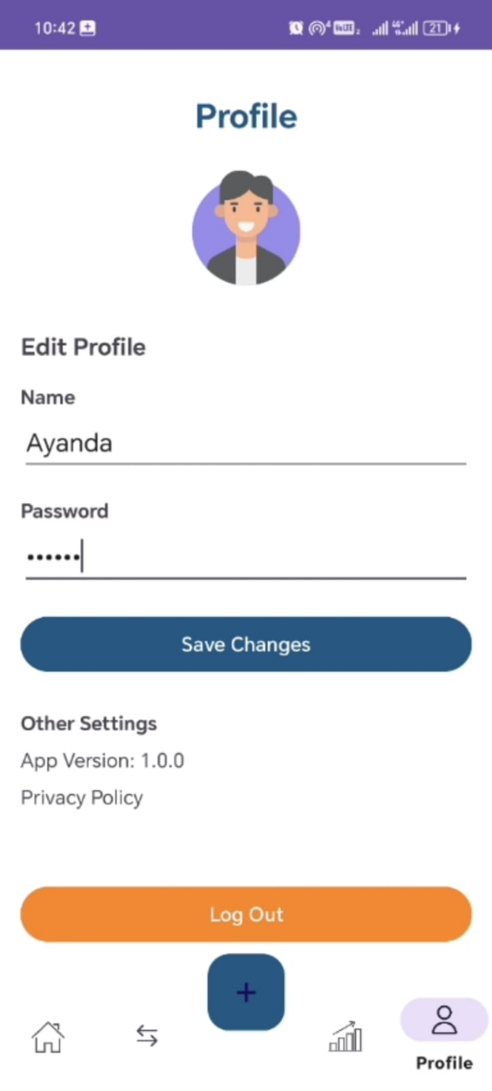

GITHUB LINK :

YOUTUBE VIDEO LINK :

<https://youtube.com/shorts/Wk4iJYJ-gCs?feature=share>

# README FILE

**INSTRUCTIONS ON HOW TO RUN THE CASH COMPASS APP:**

* Clone the repository
* Open Project in Android Studio
* Click on the file /open then navigate to the cloned CompassApp folder and open it .
* Then allow gradle sync to complete
* After connect to an android device or you can start an emulator on your right hand side.
* Run the App, by clicking on the green Run button
* You must choose your connected device or emulator to launch the App